- Draw and label a simple home network diagram showing a router, switch, and three devices (like a laptop, smartphone, and smart TV), indicating how each device connects to the network.
ANS:
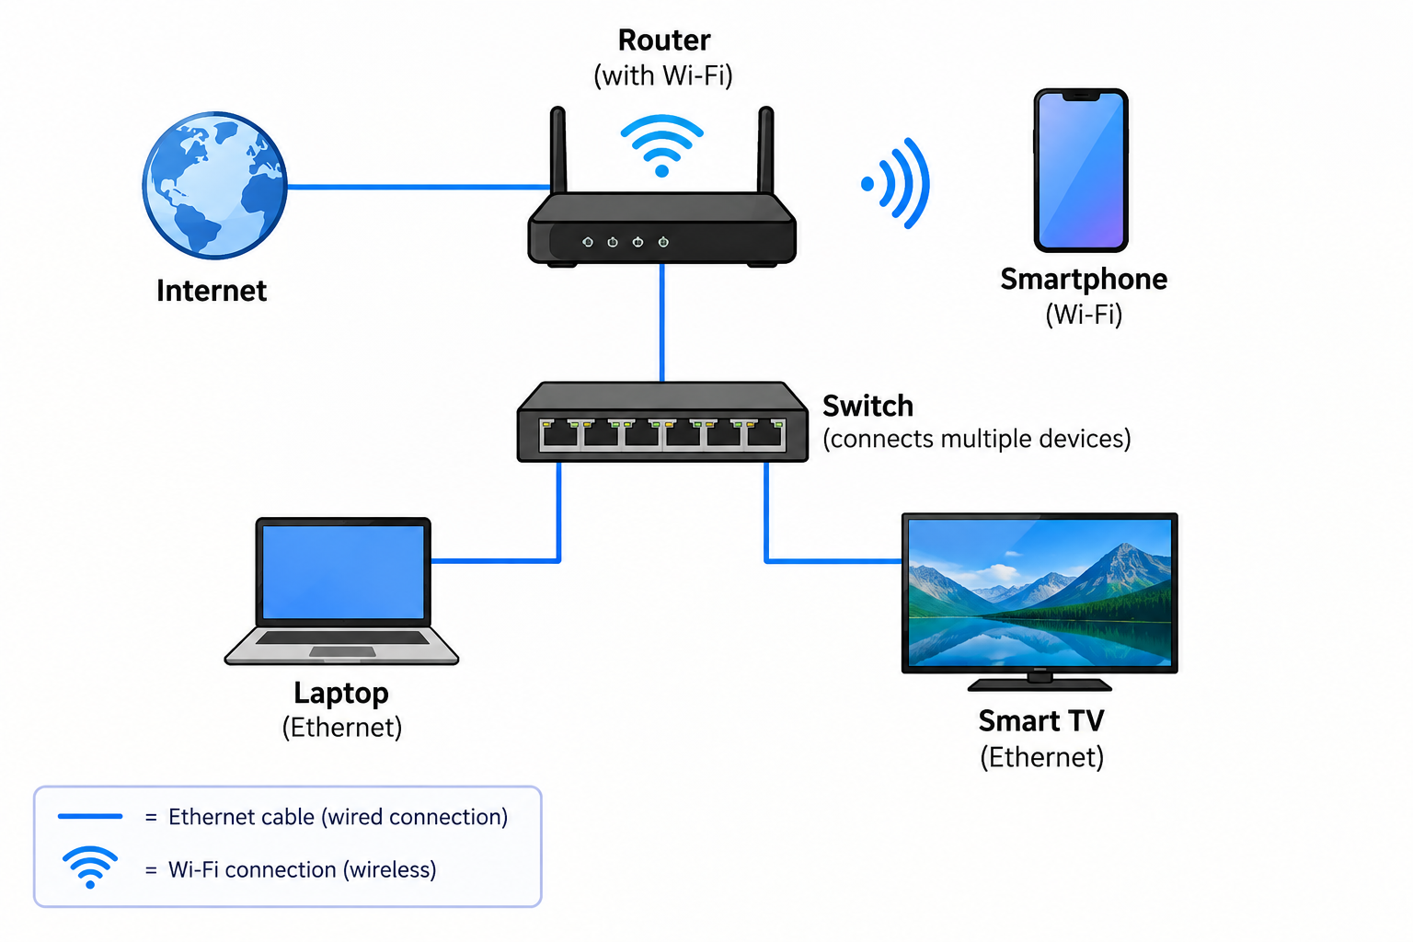

- Create a comparison table listing at least four network devices (router,switch,hub,access point) and describe one real-world use case for each,referencing apps or services you use daily (e.g., WIFI for streaming on youtube, LAN gaming,etc).
ANS:
Network Device | Real-World Use Case
Router | Provides Wi-Fi and Internet access for watching YouTube or using Instagram.
Switch | Connects multiple computers in a LAN, such as computers used for LAN gaming.
Hub | Connects multiple devices in a small network, such as older college computer labs.
Access Point | Provides wireless Wi-Fi to devices like smartphones for YouTube streaming or web browsing.
- Write a short scenario where you explain how data travels from your phone to the internet when you order food on Zomato, mentioning the role of each network device involved (router, switch, access point).
ANS:
- Access Point: My phone connects to the Wi-Fi through the access point.
- Switch: The switch forwards the data between devices within the local network.
- Router: The router sends the data from my local network to the Internet.
- Internet: The data reaches the Zomato server, which processes my food order and sends a response back to my phone.

4.Given this situation: you have a WiFi router, but your gaming PC only has an Ethernet port and is far from the router. Suggest two different network devices you could use to connect your PC to the internet and explain how each would work in this setup.<br><br><em><strong>Hint:</strong> Think about devices like switches, powerline adapters, or WiFi extenders.</em>
ANS:
- Powerline Adapter: It uses the electrical wiring of the house to send the Internet connection. One adapter connects to the router and the other connects to the gaming PC using an Ethernet cable.
- Wi-Fi Extender: It receives the Wi-Fi signal from the router and provides an Ethernet port. The gaming PC can connect to the extender using an Ethernet cable.

